OPERATING SYSTEMS
WEEK-6 Practical
Name:- SAHASRA
Roll no:- 2520030108
Section no:- 9

6Q. Create a client-server application using Named Pipes (FIFOs). The client sends messages and the server processes and responds to them. Analyze FIFO behavior when multiple clients communicate simultaneously.
Create a POSIX signal handling program that captures SIGINT, SIGTERM, and SIGUSR1. Demonstrate asynchronous event handling and explain the role of signal handlers.
Program:-
Server.c
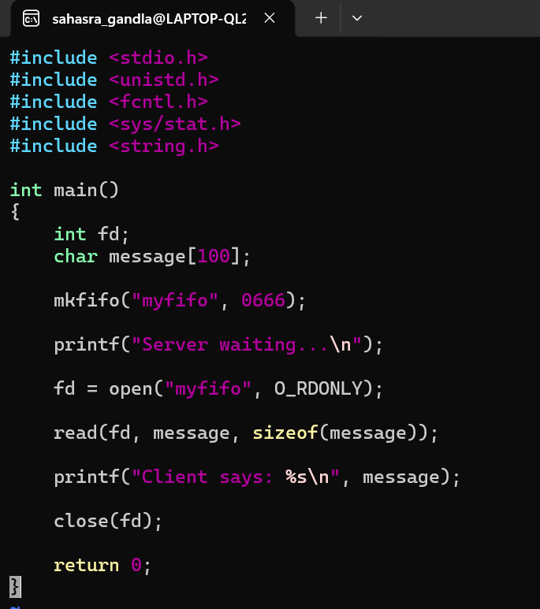

Client.c

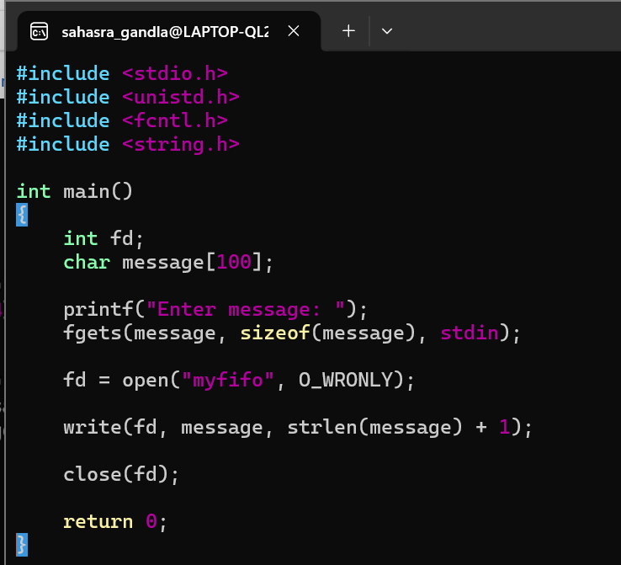
Output:-
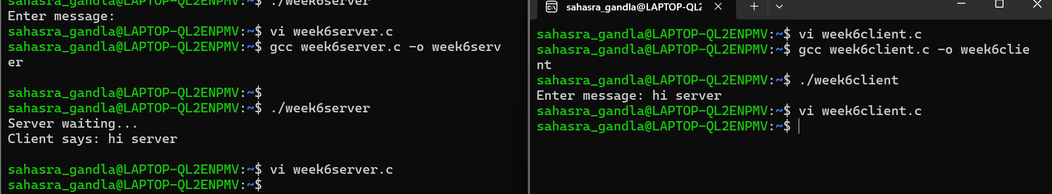
Program:
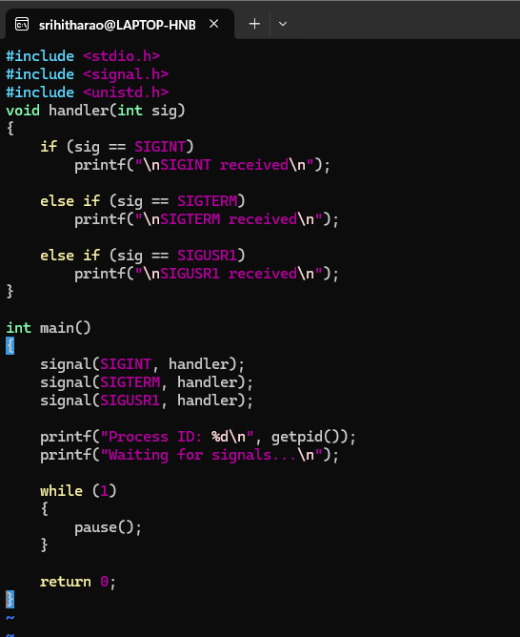

Output:
